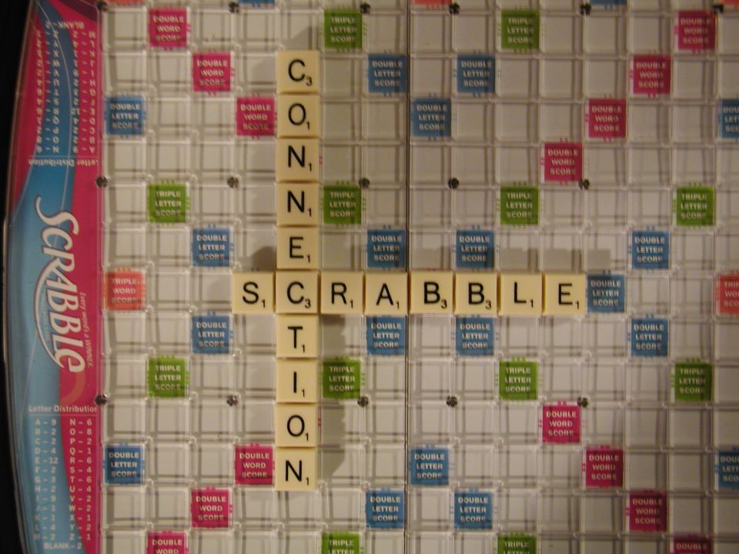
The SCRABBLE CONNECTION meets regularly (weekly) for casual, enjoyable games of scrabble!
Our game is very casual. We do consult dictionaries for spelling and for validity of words; there is no time limit for turns. For us, it's the appreciation of making a good word, keeping our brains active, learning something new and meeting new people in person. Even though many of us love Scrabble on-line, computers can be so isolating and anonymous.
We also all have busy, hectic schedules as well, so don't feel you need to be committed to participate in every game. Join us as little or as much as you like; come and go as you please.
If you would like to be informed of upcoming games, email us to join our e-mailing list. Hope to see you soon!
Scrabble-Connection scrabbleconnection@live.com

